**Setup Instructions**

1. **Setting up MySQL Database connection**
   1. **In MySQL Workbench -> create new connection clicking the “+” sign -> after configuring the Hostname, Port, Username, Password write down the information because it is needed later**
   2. **In MySQL create new schema, choose name (write down as well), click apply -> in the window paste code below:**

**Use “Your Schema Name”;**

**CREATE TABLE `admin` (**

**`username` varchar(45) DEFAULT NULL,**

**`password` varchar(45) DEFAULT NULL**

**);**

**CREATE TABLE `instructors` (**

**`instructor_id` int(11) NOT NULL,**

**`firstName` varchar(45) NOT NULL,**

**`lastName` varchar(45) NOT NULL,**

**`course` varchar(45) DEFAULT NULL,**

**`campus` varchar(45) DEFAULT NULL,**

**`building` varchar(45) DEFAULT NULL,**

**`room` varchar(45) DEFAULT NULL,**

**`checkIn` datetime DEFAULT CURRENT_TIMESTAMP,**

**`checkOut` datetime DEFAULT CURRENT_TIMESTAMP ON UPDATE CURRENT_TIMESTAMP,**

**`isCheckOut` int(11) DEFAULT '0'**

**);**

**CREATE TABLE `students` (**

**`student_id` varchar(45) NOT NULL,**

**`firstName` varchar(45) NOT NULL,**

**`lastName` varchar(45) NOT NULL,**

**`course` varchar(45) DEFAULT NULL,**

**`campus` varchar(45) DEFAULT NULL,**

**`building` varchar(45) DEFAULT NULL,**

**`room` varchar(45) DEFAULT NULL,**

**`checkIn` datetime DEFAULT CURRENT_TIMESTAMP,**

**`checkOut` datetime DEFAULT CURRENT_TIMESTAMP ON UPDATE CURRENT_TIMESTAMP,**

**`isCheckout` int(11) DEFAULT '0'**

**);**

**Like this and click apply**

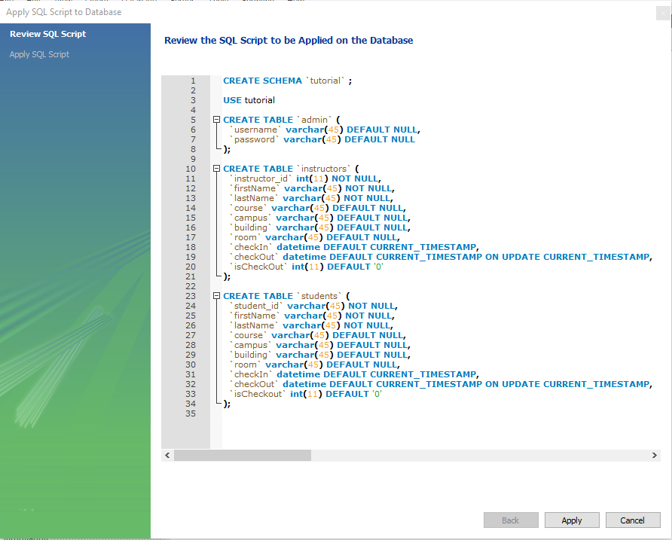

* 1. **Now you have your MySQL connection and schema setup correctly**
  2. **In the admin table enter the username and password you want to use to be able to access the admin dashboard.**
  3. **Now let’s connect the application to the database.**
  4. **In the top section of the checkIn.js file where it says “Database Connection” enter your connection information that you wrote down as prompted by comments next to the lines (//).**

1. **Running the application**
   1. **Local Hosting and Visual Studio Code**

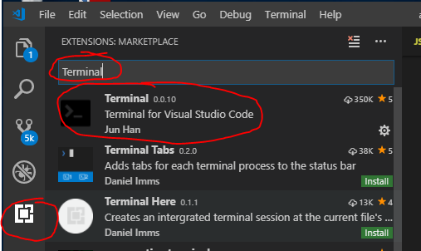

* + 1. **In the Extensions tab -> Search “Terminal” and install**
    2. **To open terminal press “CTRL + ` “ (Button under ESC)**
    3. **Using the package.json and the terminal make sure and install all dependencies in the package.json file.**

**(Run “npm install” in terminal )**

* + 1. **To run application type in Terminal -> node app.js**
    2. **When server starts up Terminal should display “Server is up and running on PORT”**
    3. **Installation complete.**